Nama: Julio

NIM: 2602118181

Figma+Prototype:

<https://www.figma.com/file/G1I4UF5nfRMtWXAq2Ydjpp/Untitled?type=design&node-id=0%3A1&t=8V5gAzCdCv75ra59-1>

https://www.figma.com/proto/G1I4UF5nfRMtWXAq2Ydjpp/VhoTel?type=design&node-id=16-2&scaling=min-zoom&page-id=0%3A1&starting-point-node-id=16%3A2

Website has 5 main pages:

1. Home Page

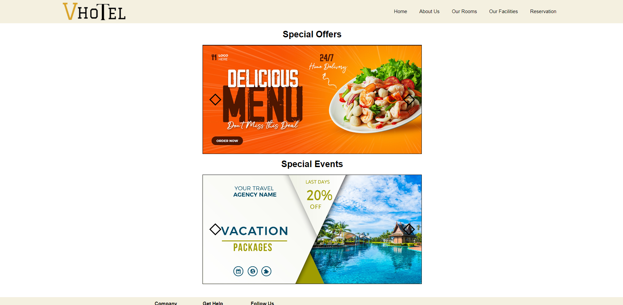

HomePage contains the promotion event banners that VhoTel is having for its guests. Web visitors can interact by clicking the previous or next button on the banner.

1. About Us Page

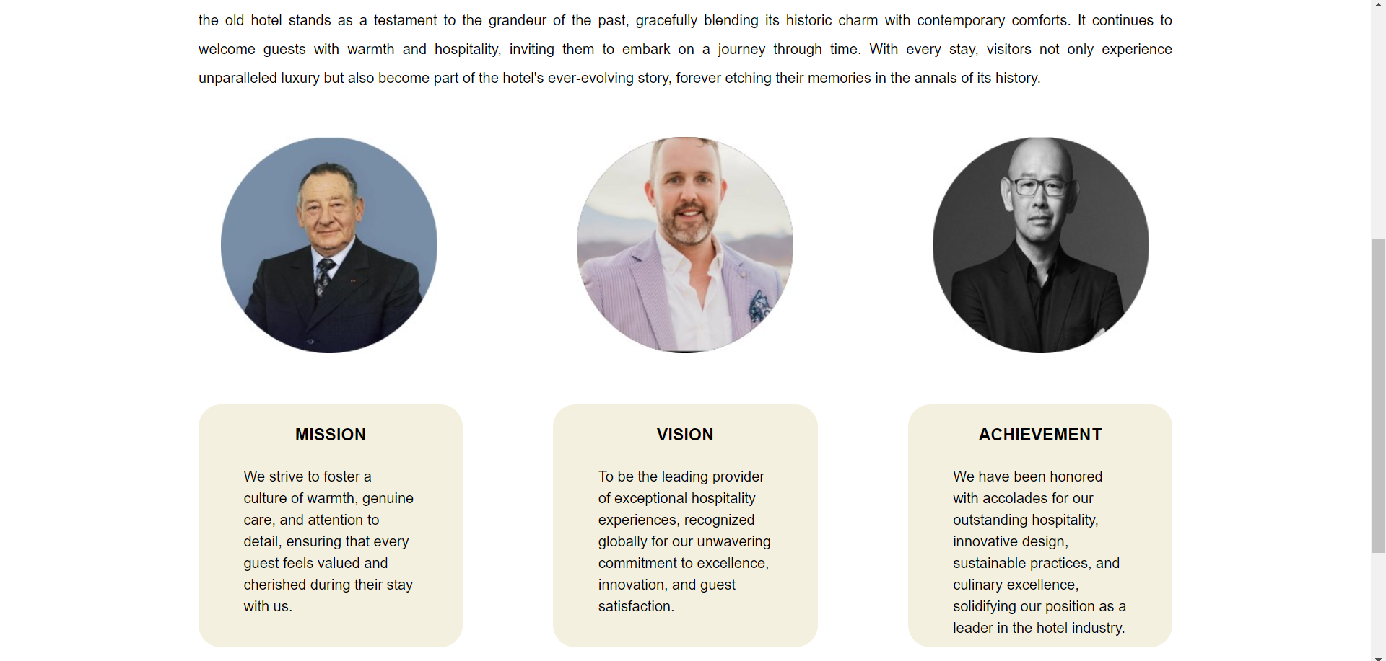

At about us page there’s a historical explanation about Vhotel, what is VhoTel, who invented VhoTel, when it was built, where it was built, why it was built. This page also displays a picture of the founder of Vhotel and describes the vision, mission and achievements so far.

1. Our Rooms Page

This page contains an explanation of the appearance of the rooms and explanations regarding the 3 types of rooms provided by Vhotel, from rooms with 1 bed, rooms with 2 beds, to rooms with 3 beds.

1. Our Facilities Page

This page contains the facilities provided by VhoTel, such as swimming pools, spas and gyms.

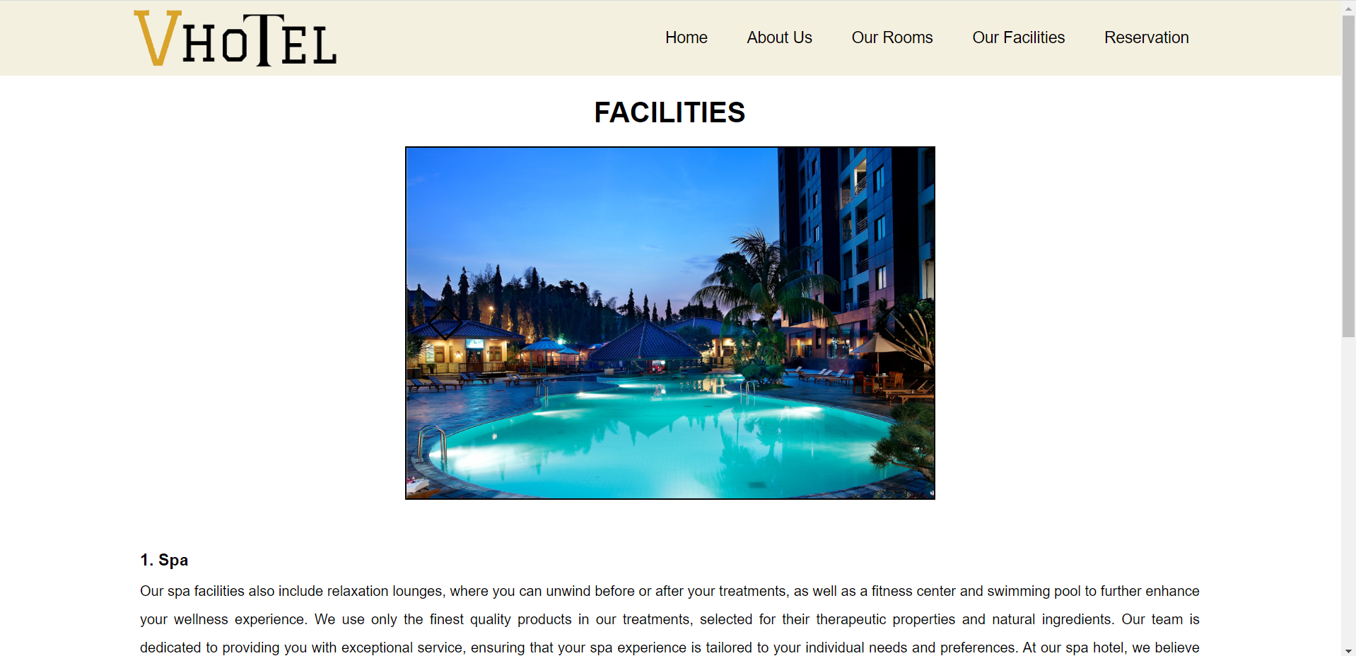

1. Reservation Page

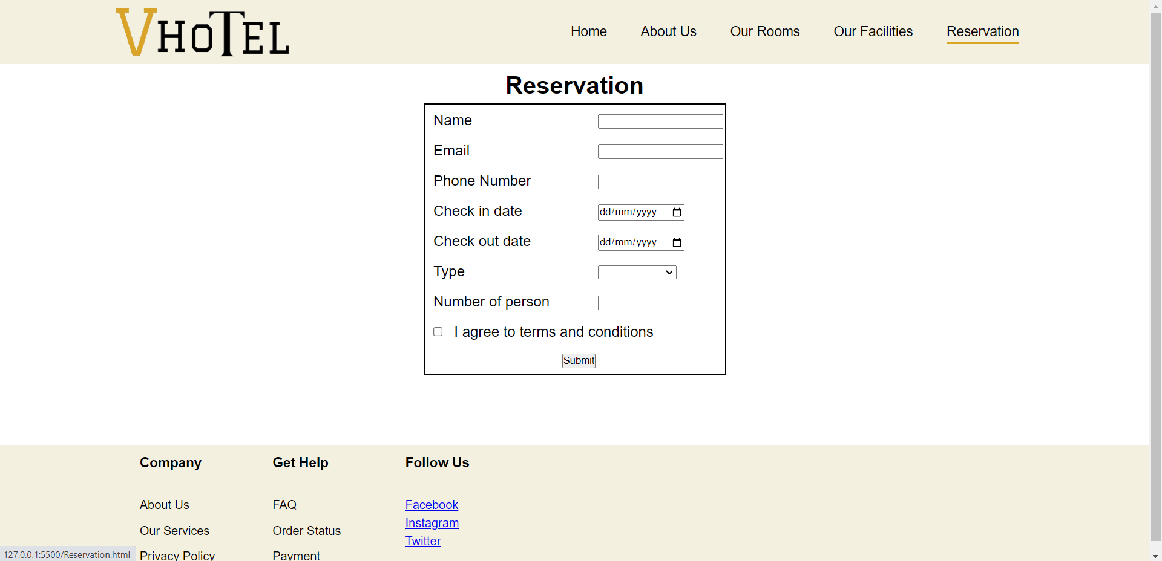

This page is a reservation section for customers who are interested in occupying a VhoTel hotel. For this reason, some necessary data is needed such as name, email, telephone number, check-in date and check-out date, desired room type, number of occupants and agreeing to existing conditions.